*Neural Networks Task 1*

# 

# 

# 

# Table of Contents

**Table of Contents 1**

**Team Information 2**

**Combination Analysis 3**

Combination #1: Adaline Model 3

Combination #1: Perceptron Model 3

Combination #2: Adaline Model 4

Combination #2: Perceptron Model 4

Combination #3: Adaline Model 5

Combination #3: Perceptron Model 5

Combination #4: Adaline Model 6

Combination #4: Perceptron Model 6

Combination #5: Adaline Model 7

Combination #5: Perceptron Model 7

**Conclusion 8**

# 

# Team Information

**Team ID: 5**

| **Member name** | **Department** | **Email** |
| --- | --- | --- |
| عمر احمد فاروق احمد الجبالي | CS | 20201701162@cis.asu.edu.eg |
| عماد محمود عمر الفاروق محمود | CS | 20201700517@cis.asu.edu.eg |
| عمر احمد محمد عبدالمعطي | CS | 20201700524@cis.asu.edu.eg |
| عمر عبدالفتاح عبدالسميع ابراهيم | CS | 20201700538@cis.asu.edu.eg |
| محمد ابراهيم سعيد امام | CS | 20201700650@cis.asu.edu.eg |
| محمد اسامه كمال يوسف | CS | 20201700665@cis.asu.edu.eg |

# **Combination Analysis**

## **Combination #1:** *Adaline Model*

* Features: (Area, Perimeter)
* Classes: (Bombay, Cali)
* Accuracy: 100%

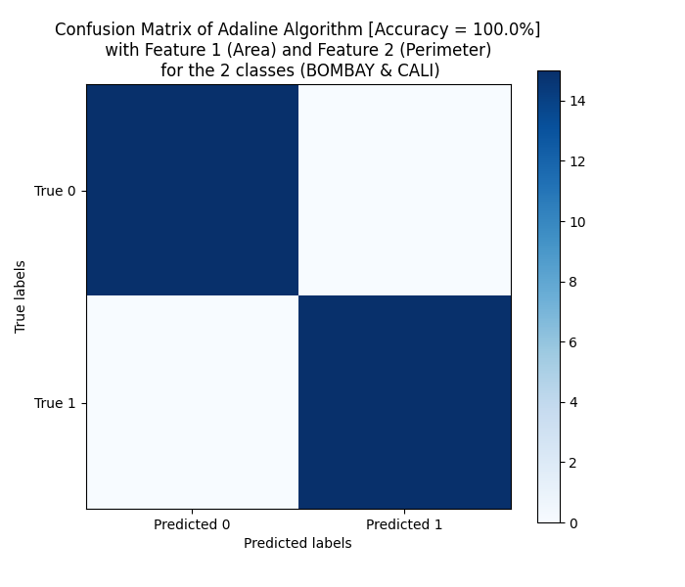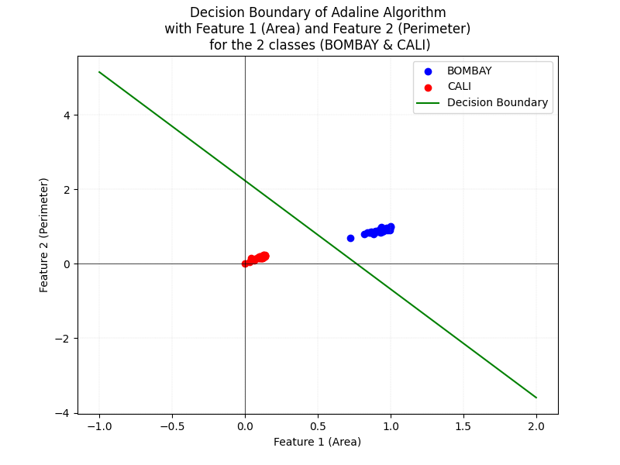

## **Combination #1:** *Perceptron Model*

* Features: (Area, Perimeter)
* Classes: (Bombay, Cali)
* Accuracy: 100%

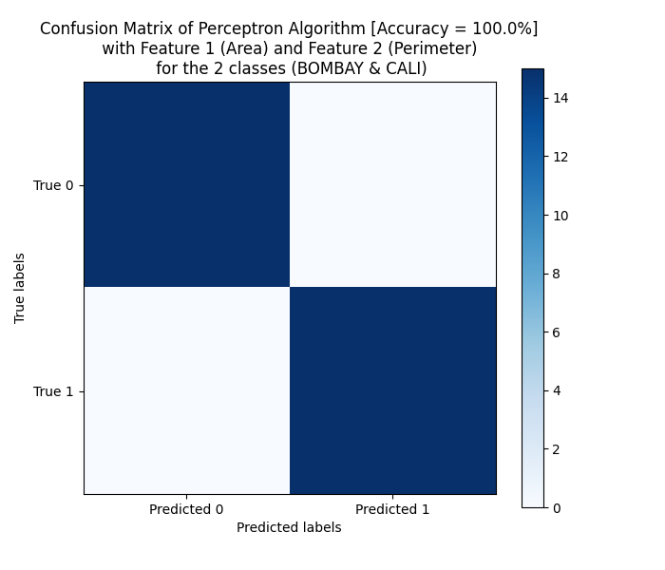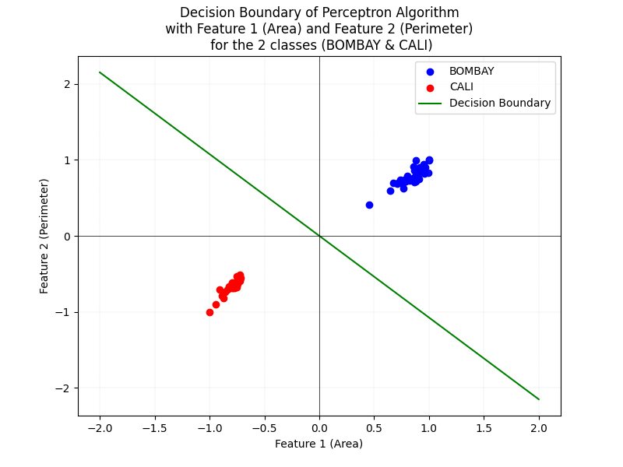

## 

## **Combination #2:** *Adaline Model*

* Features: (MajorAxisLength, Area)
* Classes: (Bombay, Sira)
* Accuracy: 100%

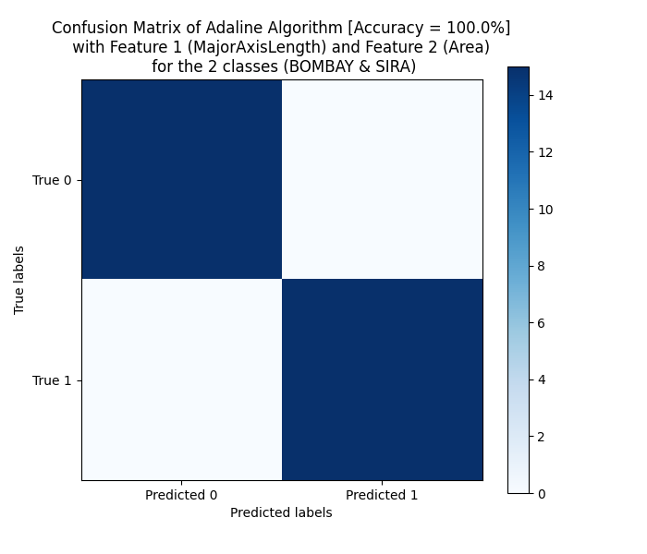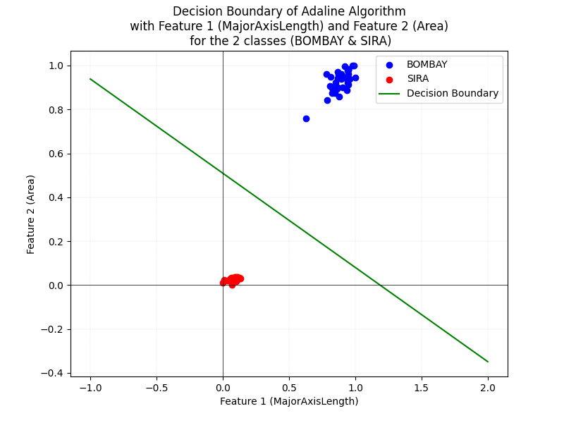

## **Combination #2:** *Perceptron Model*

* Features: (MajorAxisLength, Area)
* Classes: (Bombay, Sira)
* Accuracy: 100%

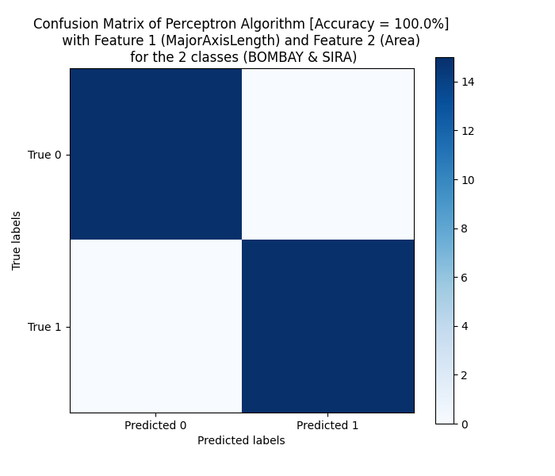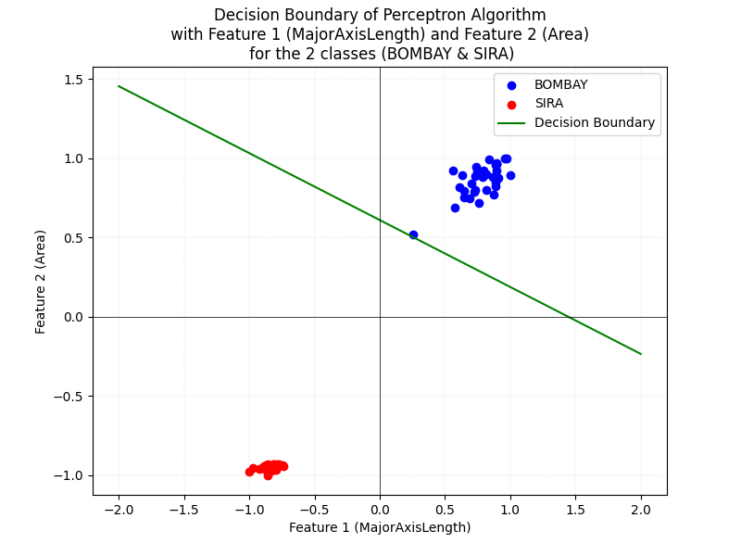

## 

## **Combination #3:** *Adaline Model*

* Features: (MajorAxisLength, MinorAxisLength)
* Classes: (Cali, Sira)
* Accuracy: 100%

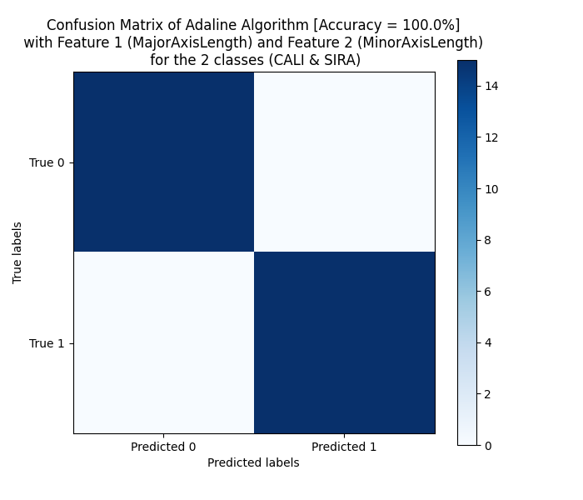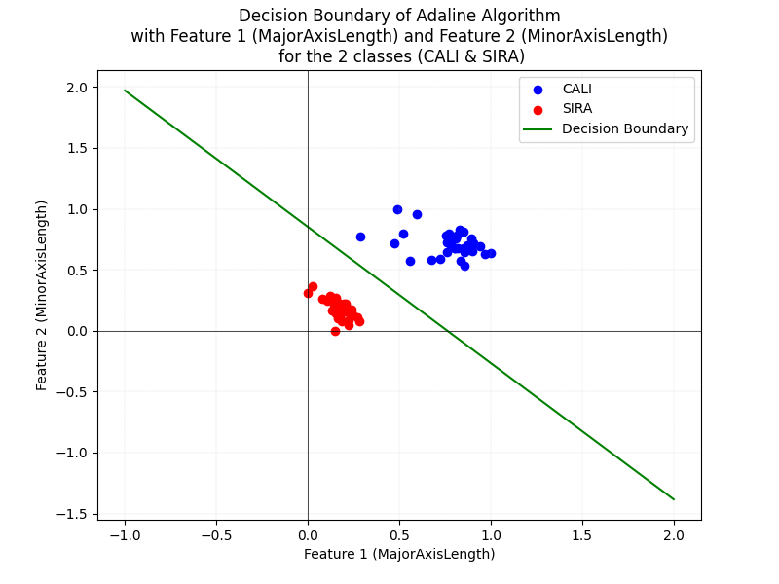

## **Combination #3:** *Perceptron Model*

* Features: (MajorAxisLength, MinorAxisLength)
* Classes: (Cali, Sira)
* Accuracy: 100%

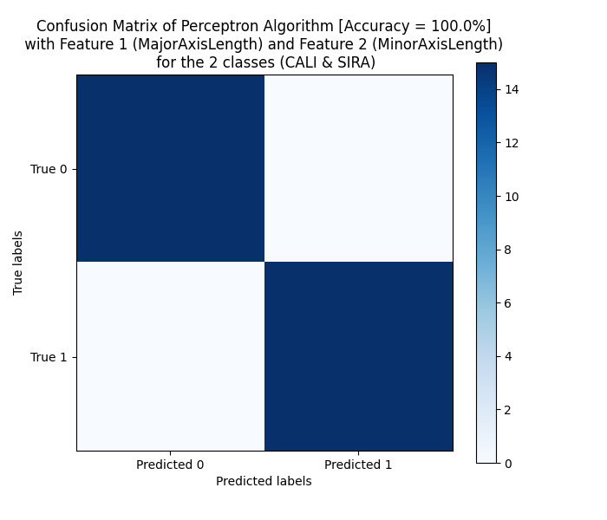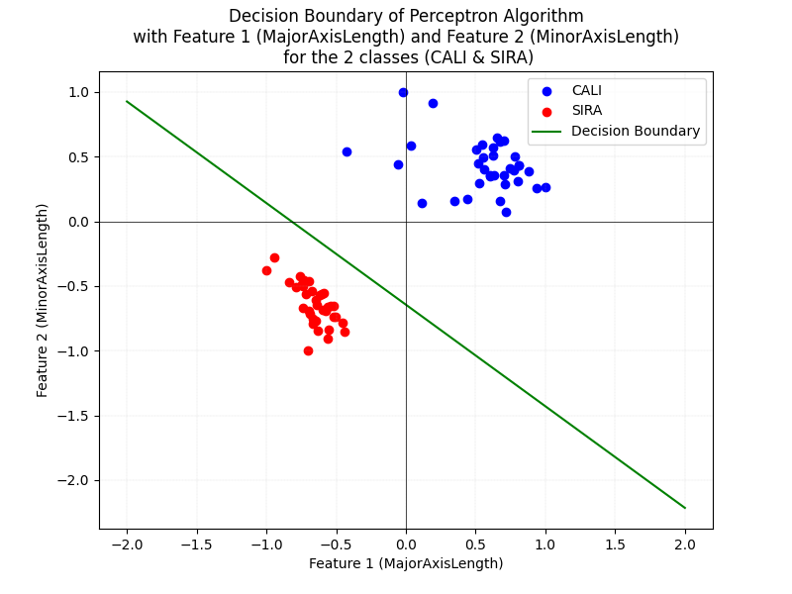

## 

## **Combination #4:** *Adaline Model*

* Features: (MinorAxisLength, roundnes)
* Classes: (Cali, Sira)
* Accuracy: 93.3%

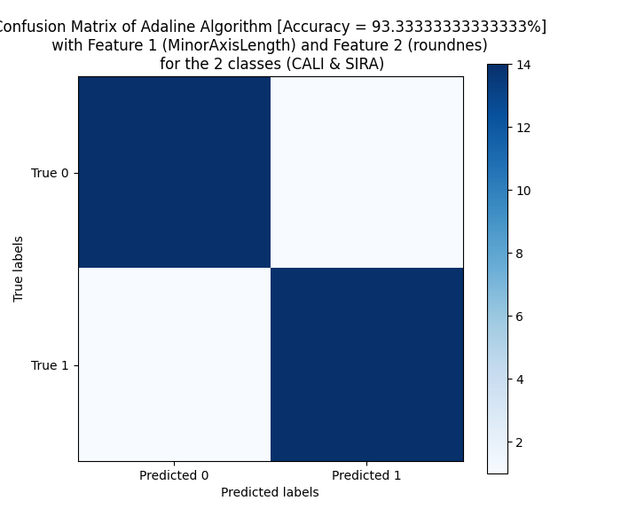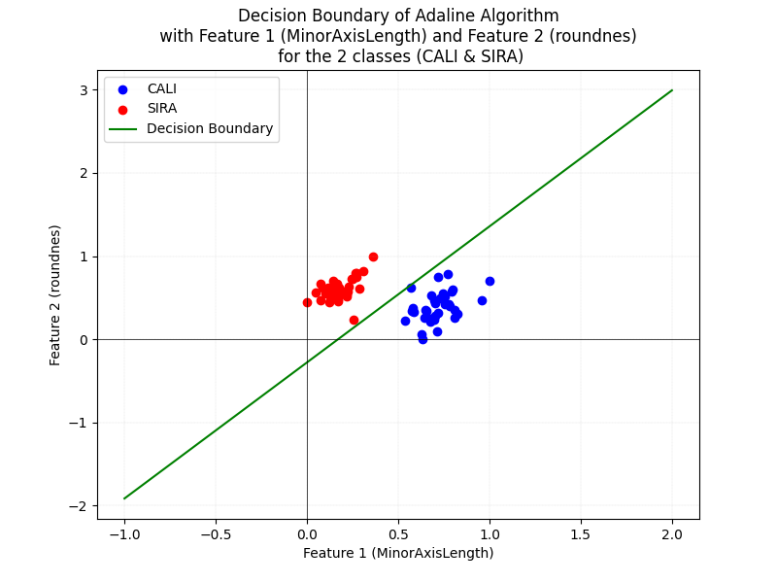

## **Combination #4:** *Perceptron Model*

* Features: (MinorAxisLength, roundnes)
* Classes: (Cali, Sira)
* Accuracy: 93.3%

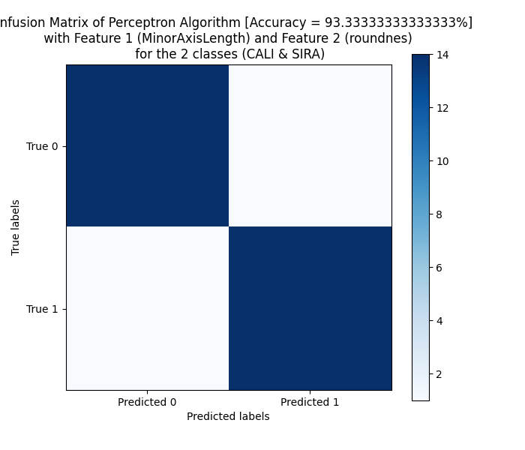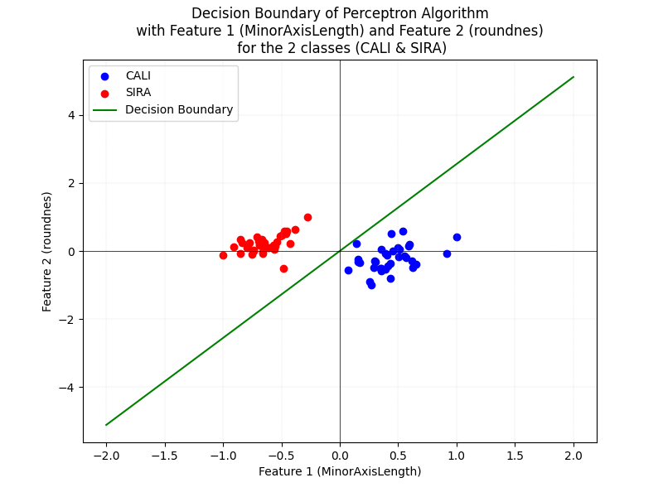

## 

## **Combination #5:** *Adaline Model*

* Features: (roundnes, Perimeter)
* Classes: (Bombay, Cali)
* Accuracy: 100%

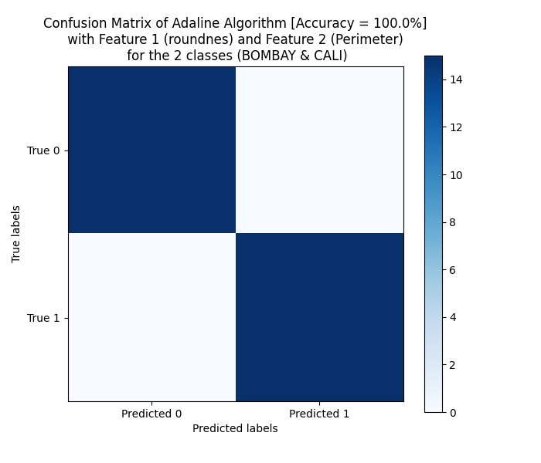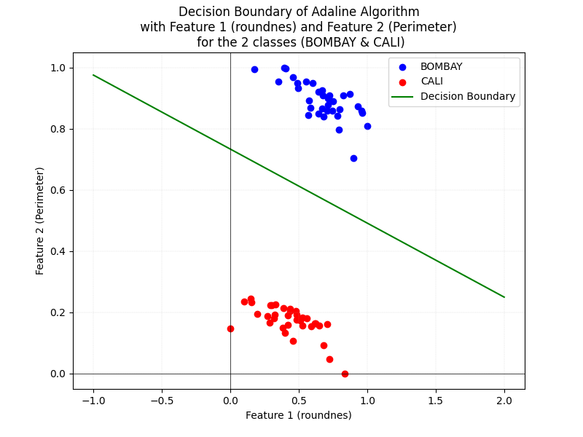

## **Combination #5:** *Perceptron Model*

* Features: (roundnes, Perimeter)
* Classes: (Bombay, Cali)
* Accuracy: 100%

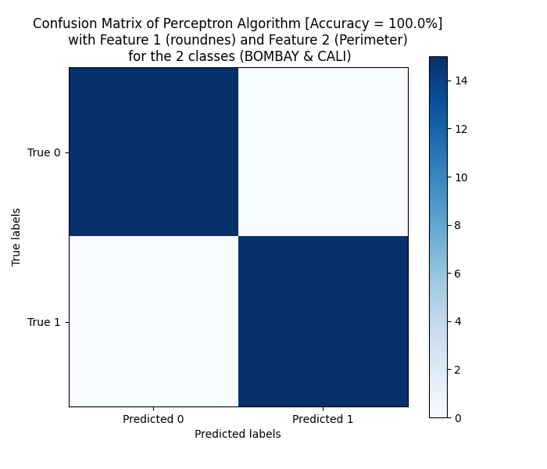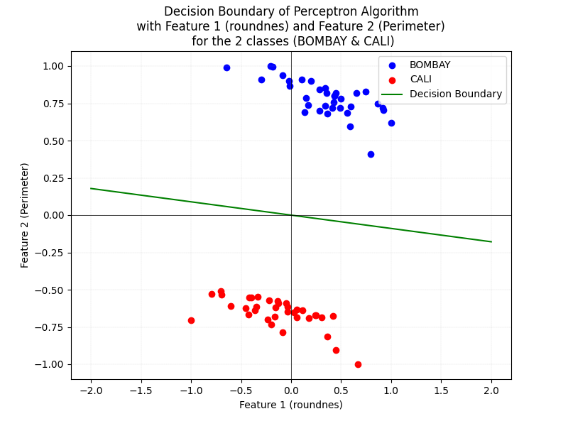

# **Conclusion**

In conclusion, we deduce that the best features for the given algorithms - which are Adaline and Perceptron - and which gave the highest accuracy are all of them except the only combination of features that didn’t get **100%** accuracy are *MinorAxisLength* and *Roundness* which only got **93%** accuracy.

All of the features used in this sample combination gave a **decision boundary** that divides (discriminates) between the two classes mentioned in the same combination. Still, they differ in how evenly spaced the classes are (regarding **SVM** and how it maximizes the margins).